Valeriy Kutsar

Screenshot of webserver working from terminal

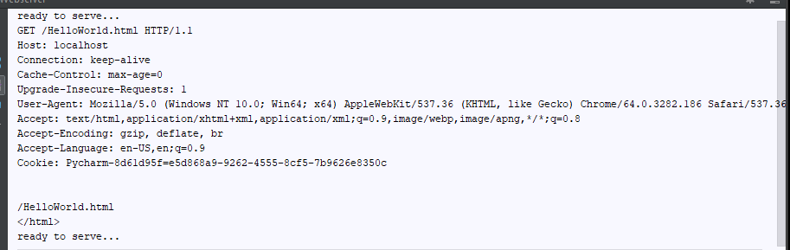

Screenshot displaying file in the web browser with terminal

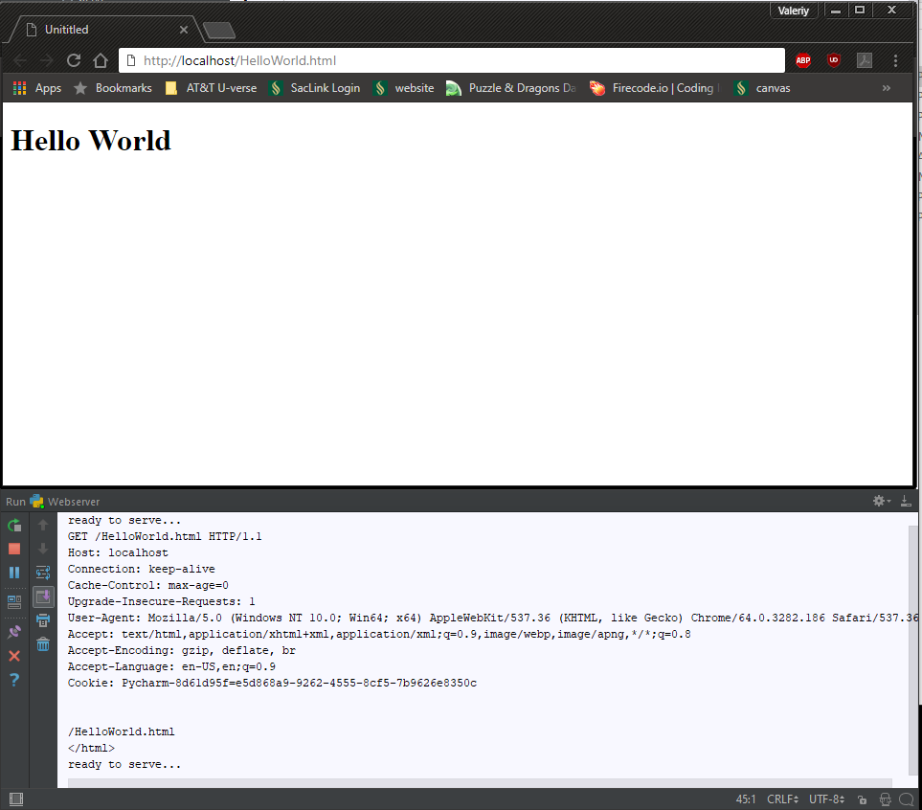

404 message when looking for Helloorld.html instead of HelloWorld.html

